RELEASE NOTES

September 2022

Version Content

Advanced Body Field for Wallet Pass and Export Event……………………………………………………………..3
Open New tab Option 3
Navigating back anchor Support from an Activity 4
Auto-Complete Member Tag Support for Pointshop Items 4
App Action Support for Businesses on Essentials 5
Filter by Trigger within the Campaign Center 6
Transaction information Tool Tip for Budget Transaction 6
A/B Testing Greyed Out and Tooltip is shown when Population is too Small: 7
Save Button for Social Connect Feature 8
External Registration Field name Enabled for “Como Support” Role: 8
Como Agent 9
Latest App Version 9
Bug Fixes 10

Export Event / Wallet Pass Communication actions add new advanced body field with Support for mentions
A new advanced text body has been added on actions for export events and wallet pass communications. In addition, you can add mentions (dynamic text) such as a member’s first name to make the messages more personal.
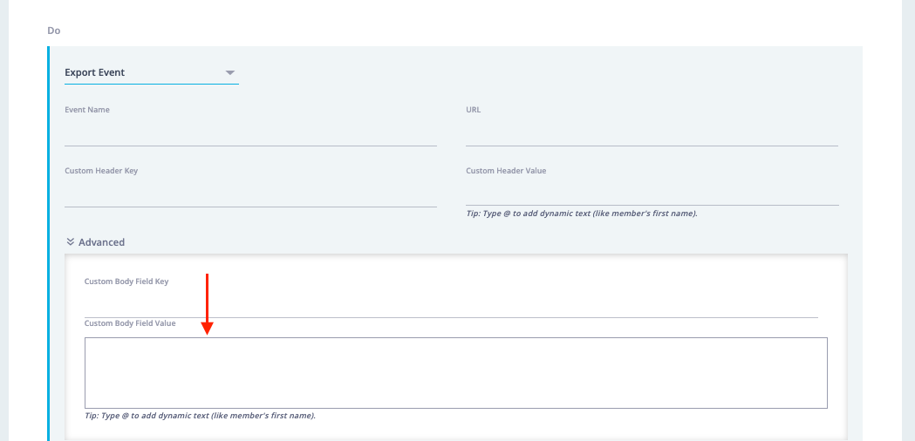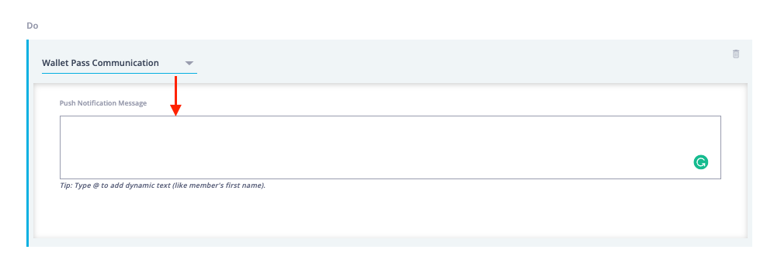

Open New tab Option
A new button of “Open in new tab” has been added within the settings of Gifts, Promo Codes, Emails, Point Shop Items, and activities within the Campaign Center. Doing so, will keep the original tab open allowing the user to dive into the activity with ease of navigating back.
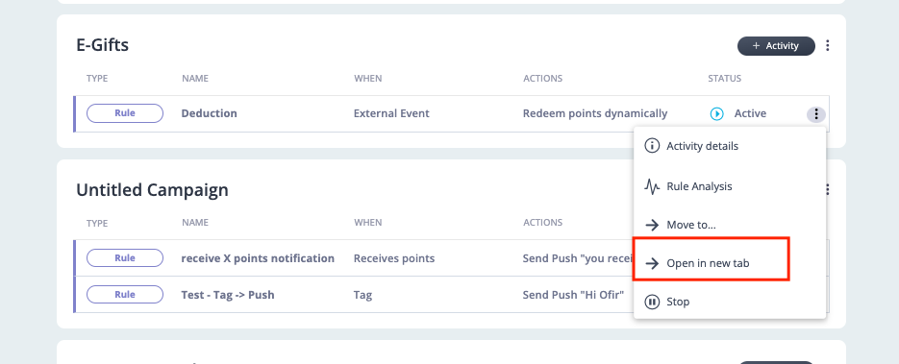

Navigating back anchor Support from an Activity
Until now, if you were on the Campaign Center and you navigated within a given activity and then hit the back button, it would take you back to the top of the Campaign Center Page. Now, when navigating back, it will take you to the same spot you were when selecting the specific activity. This is very useful in businesses that have quite a few Campaigns where it isn’t easy to locate where you were previously.
Demo:

Auto-Complete Member Tag Support for Pointshop Items
Member tags are supported within Pointshop items allowing a business to restrict visibility based on a given Member tag. Previously, manual input was required whereas now autocomplete Tag suggestions will appear allowing the business to define with ease.
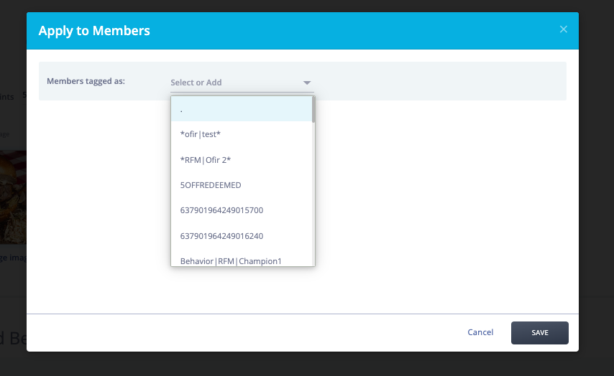

App Action Support for Businesses on Essentials
Businesses on the essentials plan that have an app, can now run app actions such as sending a push notification and in-app message. These actions were previously locked in all essential businesses even if they had an app.
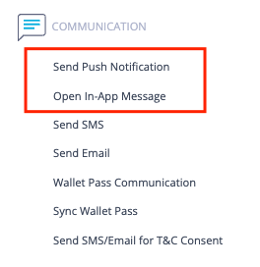

Filter by Trigger within the Campaign Center
Businesses can now use the Filter by Trigger Tab within the Campaign Center to view activities based on a specific action trigger. This is very useful in businesses that have quite a few Campaigns where it isn’t easy to locate each campaign and action.

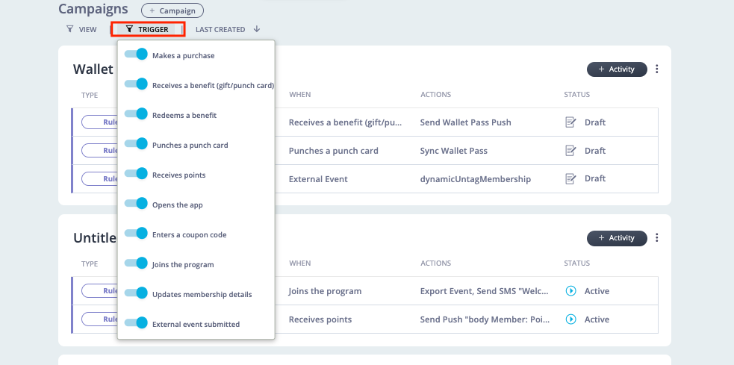
Transaction information Tool Tip for Budget Transaction
When using Pay for points/credits at the POS, a tooltip has been added to the member activity log displaying information of the Transaction.

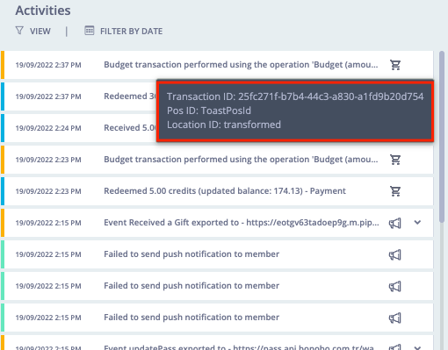

A/B Testing Greyed Out and Tooltip is shown when Population is too Small:
Previously, when running a one-time action, the A/B testing feature was hidden completely when the population was under the minimum requirement (500 members). Now, the feature will appear greyed out with the tooltip containing a message of the minimum population requirement.
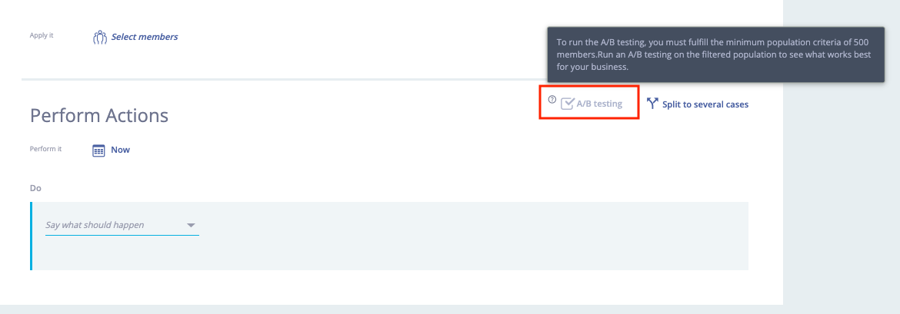

Save Button for Social Connect Feature
The save button under the Social Connect feature was previously hidden when no information was added within the Hub. Now, the button will appear but greyed out until the information is input within the fields.

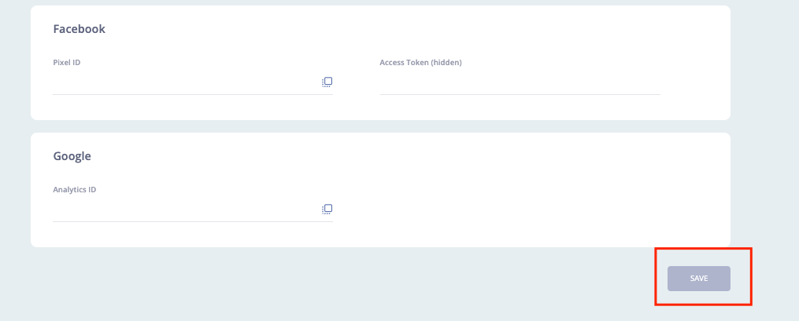

External Registration Field name Enabled for “Como Support” Role:
External Registration Field names are very sensitive as updating will affect member registration info sent over via Registration API. Furthermore, if not mapped correctly imports will fail. To ensure consistency, external registration field names cannot be altered. Support Role Hub users will be able to edit the field based on requests sent directly to support.

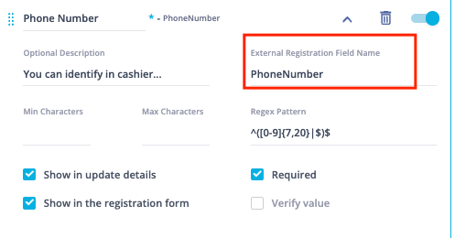

Como Developer Docs
https://docs.bcomo.com/Identity/Account/Login

Latest App Version

Android Version: 3.0.6 - new version (minimum Android version supported - 5)
iOS Version: 3.0.6 - new version (minimum iOS version supported - 12)
Phoenix Version: 2.2.14 - new version
- Minimum binary version iOS: 3.0.6
- Minimum binary version android: 3.0.6

Bug Fixes
- Open asset screen - 2786039011 - crash end case
- Open asset screen - 2786039011
- Share Credits background color - 2951105970
- General Info screen - description direction - 1583674001
- Points on tile not showing - 1959726758
- Punch Card Design Crops - 1540370947
- Adjust Android build for Android 12 (API level 31)
- Accessibility - 1832533498
- Accessibility - 1832533498
- Catalog back button - partial fix - 2902445475

